Science  Keep a food diary for 5 days – write down exactly what you have to eat and drink and what times you have them. Read the labels of the foods you are eating. How many calories are you eating? Read the ingredients – is there anything that surprises you? | Art/DT  The Ancient Mayans discovered how to make chocolate!  Design your own new chocolate bar, name and wrapper. What does it look like? What is it made from? It must include chocolate, but could it have, biscuit, nougat, raisins, caramel, fudge, popping candy, mint or something else in it? NO NUTS  Can you actually make it? | Maths  Can you find some fractions around your home?  Count the rooms in your house and make up some fractions. 8/8 of the rooms have windows, 3/8 of the rooms have pillows in,  1/8 of the rooms has a bath,  2/8 of the rooms have a sink,  6/8 of the rooms have a chair in them, 0/8 of the rooms have an elephant in! Can you find some equivalent fractions 2/8 = 1/4 | Art/DT  Design an Ancient Mayan temple, you could draw it, make it out of junk materials or build it out of Lego.  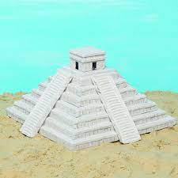  Why were the temples so important to the Mayans? | Maths  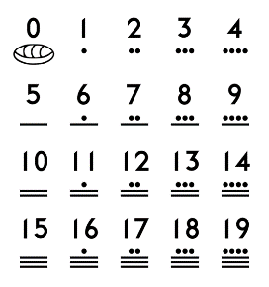  The Ancient Maya had a base number system up to 20. Can you create your own additions and subtractions within 20 using the Mayan number system?
History  Find out about Ancient Mayan warriors. You could draw and label one.  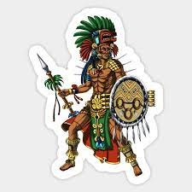  What did they do? What was life like for a Mayan warrior? What weapons did they have? Can you find out about an Ancient Mayan battle? | English  Research an ancient Mayan myth and write it in your own words.  Can you include some good descriptive words? (Adjectives) | Science  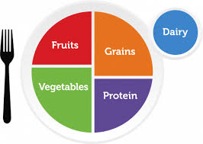  Draw and label your perfect meal. What are the main food groups of you dish? | Music  Create a rainmaker using pebbles, or seeds, or rice etc.  Can you decorate it with a theme? | English  You are trekking through the jungles of South America and happen to stumble upon a lost civilisation. Write a diary entry about your discovery.
Maths  Practise some addition, subtraction, multiplication and division.  Remember – you should be practising your times tables everyday. | Geography  Where did the Ancient Mayans live?  Could you find a map and label some key Ancient Mayan cities? | RE  Learn about an ancient Mayan God. What do you think they might have looked like? Did they have any supernatural powers? Who prayed to them and why? | English  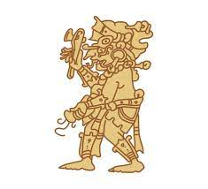  Write a small fact file about anything that interests you to do with the Ancient Mayans. You could include pictures, drawings, Fun Facts and lots of information. | History  Can you compare an Ancient Maya house to an Anglo-Saxon house? How were they the same? How were they different?
Geography  Create a holiday brochure for visiting Mexico. What facts can you find? What do they eat? What are the big tourist attractions? | Computing/IT  CODE  Computing systems use code to create programs. Can you design your own alphabet code? A picture or symbol could represent a letter from the alphabet. | 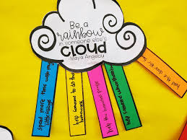  PSHE/RSE  ‘Be a rainbow in someone’s cloud.’ What could you do to make someone happy? | DT  Can you create a Mayan Headdress with feathers and jewels? | Free Choice x 2  Draw, design, make, build, write or research about anything you like!

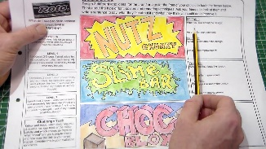
Please complete one activity a week and cross off the ones you have completed. Stuck? Come and ask Mr. Gachowicz, Miss. Claxton or Mrs. Wallis for help.
Remember, it is expected you read daily at home for 10-15 minutes. Record this in your communication diary. Fill out a book review if you finish a book.
You have your weekly spellings too. These can also be found on SpellingShed. Use your TacklingTables Log-in to practise your times tables and division facts online.

