Geography  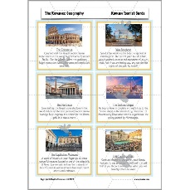  Create some tourist cards of the top 10 things you can see and do in Rome. | Science  Do some flower pressing. Press flowers between the pages of a heavy book. Stick in your book when dry and label the different parts of the plant.  OR  Write a list of the foods you eat which come from plants. Are you eating the seeds, the fruit, the leaves, the roots, the bulb? | Maths  Practise your times tables. Choose the ones you are least confident with.  Practise your speed tables  https://www.timestables.co.uk/  multiplication-tables-check/  Practise on MathShed | Maths  Look around your home. Can you find objects which you can classify as 2D or 3D shapes?  The clock is a circle, the TV is a cuboid, the can of beans is a cylinder. Are there any triangles? | Science  Choose an animal and think about their habitat. Present in any way you like.  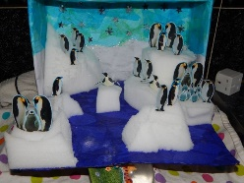  Why are they suited to this habitat?
History  Draw and label a Roman centurion soldier. Why was the Roman army so effective? | Art  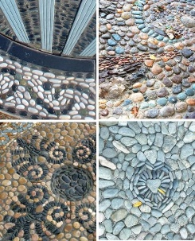  Create a mosaic using natural materials. You could use pebbles, shells, seeds, leaves? | DT  Build a roman temple, complete with roman architecture, furniture and decoration.  OR  Build a Roman aqueduct that can actually carry water along it. | RE  Jupiter, Juno, Mars, Mercury, Neptune, Venus, Apollo, Diana, Minerva, Ceres, Vulcan, and Vesta.  Choose one of these Roman Gods and present some information on them. Be creative. | Maths  Can you use Roman Numerals to write and solve some addition and subtraction problems.  VII + XX = XXVII  XV – VI = IX
English  Write a biography on one of these Roman Emperors:  Caesar Augustus  Nero  Hadrian  Constantine the Great  Trajan | RSE/PSHE  To recognise how our bodies change as we grow older.  Draw yourself as a baby, a toddler, a child, a teenager, a young adult, an adult, an old person. What did you, do you and will you look like? What will you wear? What will you do? What kind of person will you be? | RE  Choose either Christian Aid or Muslim Charity. How do these religious groups contribute to the world through their charity work? | History  The Colosseum in Rome held games and events including gladiator fights. Create a poster advertising one of these events.  OR  Create a poster for an event at the Roman Hippodrome including chariot racing. | Reasoning  ‘What did the Romans ever do for us?’  The Romans did a lot for the modern world. Do you agree or disagree and explain why?
English  Write a comic strip about the day in the life of an ordinary Roman.  OR  Write a diary entry from a Roman soldier travelling to Britannia from Rome  OR  Write an acrostic poem about the Romans. | Science  Grow a sunflower seed and keep a record of its height in a table. Who can grow the tallest in the class? 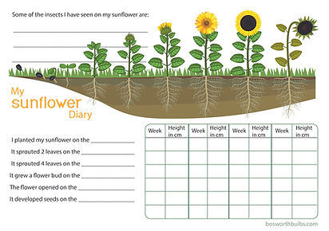 | Computing/IT  An algorithm is a set of instructions. We use algorithms in coding to make something behave exactly how we want it to. If the code is wrong, the program won’t work properly.  Write a detailed and specific set of instructions for an everyday task.  Brushing your teeth, getting to school, making a sandwich?? Be as detailed and specific as you can. | Art  To link with our science, paint, draw or make a flowers.  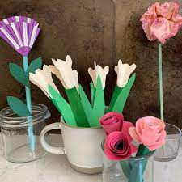  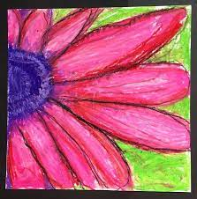 | Free Choice x2  Choose something which interests you and present it in any way you like.

At KS2 it is expected that all children are reading daily at home for at least 15 minutes. Please record this in your communication diary, by putting the short date, book title and page number.
Learning your times tables at home as well as at school will help with your fluency and quick recall of your tables.
Homework will be handed out on a Friday and due in the following Wednesday. Please pick one of these options a week and complete a long with your weekly spellings. Remember, if you are unsure of a word in your spellings, find out the meaning and practise by putting it into sentences. Spellings can be practised on SpellingShed.
If you need any resources or help with ideas, please come and ask Mr. Gachowicz.

