INGOLDISTHORPE C of E PRIMARY SCHOOL
Policies
Lockdown Procedures & Policy.
Original signed copies in staff room with copies on: website, intranet and office.
May 2021
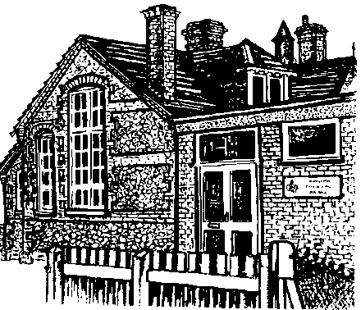
Signed: Chairman of Governors Date: May 2021
Signed: Head teacher Date: May 2021
Reviewed by Governors May 2021
Ratified at the May meeting.
Policy to be reviewed Summer Term 2023.
Lock Down Policy and Procedures
Rationale
As part of our Health and Safety policies and procedures the school has a Lockdown Policy. On very rare occasions it may be necessary to seal off the school so that it is not able to be entered from the outside. This will ensure that pupils, staff and visitors are safe in situations where there is a hazard in the school grounds or outside the school in the near vicinity. A lockdown is implemented when there is serious security risks of the premises due to, for example, near-by chemical spillage, proximity of dangerous dogs, serious weather conditions or attempted access by unauthorised persons intent in causing harm/damage.
NaCTSO (National Counter Terrorism Security Office) **Guidance**
In January 2016, NaCTSO provided the following advice to leaders of schools and other Educational Establishments for Reviewing Protective Security.
Bomb threats: Procedures for handling bomb threats
Most bomb threats are made over the phone and the overwhelming majority are hoaxes, made with the intent of causing alarm and disruption. Any hoax is a crime and, no matter how ridiculous or unconvincing, must be reported to the police.
Be alert, but not alarmed! On receipt of a “bomb threat” - Dial 999 and police will respond. You should always consider their advice before a decision is taken to close or evacuate.
Notification of Lockdown
Staff will be notified lock down procedures are to immediately take place on hearing short bursts of air horns from halls and playground. The internal phone system will also be use by office staff who will inform adults by stating’ ATTENTION LOCK DOWN’
Procedures:
1. These signals will activate a process of children being ushered into the school building or log cabins if on the playground or field as quickly as possible and the locking of the school’s offices, fob connecting doors and all outside doors where it is possible to remain safe.
2. At the given signal the children remain in the room they are in and the staff will ensure the windows and doors are locked and screened where possible and children are positioned away from possible sightlines from external windows/doors. Lights, interactive white boards and computer monitors to be turned off.
3. Children or staff not in class for any reason will proceed to the nearest occupied classroom and remain with that class and class teacher e.g. children using toilets when siren goes. If a class is in the hall from where their classroom is they are to go to one of the nearest rooms e.g. activities room.
4. If practicable staff should notify the front office by phone that they have entered lock down and those children not accounted for.
NO ONE SHOULD MOVE ABOUT THE SCHOOL
5. Staff to support children in keeping calm and quiet.
6. Staff to remain in lockdown positions until informed by the Head or Deputy Head teacher.
7. As soon as possible after the lockdown teachers return to their base classrooms and conduct a roll call and notify the office immediately of any pupils not accounted for.
Staff Roles:
1. Front office staff ensure that their office is locked and police called if necessary.
2. Head or office staff member locks the school’s front doors and entrances.
3. Individual teachers/HLTAs/TAs lock/close classroom door(s) and windows. Nearest adult to check exit doors in KS2/KS1/EYFS/Nursery are locked.
4. Catering Staff and lunchtime staff to lock back door to kitchen and turn off lights if at lunch time..
INDIVIDUAL STAFF CANNOT SIGN OUT OR LEAVE THE PREMISES DURING LOCKDOWN WITHOUT PRIOR AGREEMENT OF THE HEADTEACHER BEFORE LEAVING
Communication with parents
• If necessary parents will be notified as soon as it is practical to do so via the school’s established communication network – Parentmail/ text/telephone.
• Depending on the type and severity of the incident, parents may be asked NOT to collect their children from school as it may put them and their child at risk.
• Pupils will not be released to parents during a lock down.
• Parents will be asked not to call school as this may tie up emergency lines.
• If the end of the day is extended due to the lock down, parents will be notified and will receive information about the time and place pupils can be picked up from office staff or emergency services.
• A letter to parents will be sent home as the nearest possible day following any serious incident to inform parents of context of lockdown and to encourage parent to reinforce with their children the importance of following procedures in these very rare circumstances.
Lockdown drills
Lock down practices will take place once a term to ensure everyone knows exactly what to do in such a situation. Monitoring of practices will take place and debriefed to staff so improvements can be made.
Additional information
Guidance on receipt of a bomb threat: https://www.gov.uk/government/publications/bomb-threats-guidance

