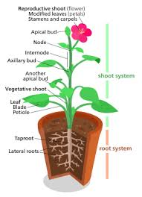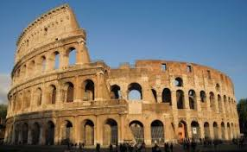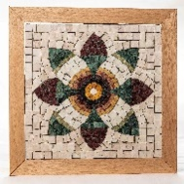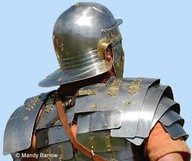

Maths – There will be a focus on ‘catch-up’ provision and ensuring children are confident in number work and the use of the four operations and methods they have learnt.

Year 3

The children will be learning how to read and write time. We will calculate amounts of money and work out the change from £10. We will begin to look at the perimeter of shapes and learn to measure length, weight and capacity.

Year 4

In addition to the year 3 objectives, the children will plot coordinates on a grid, work out the area of a shape and look at lines of symmetry.

Music

We will be looking at basic notation and play simple tunes on the glockenspiel. We will look at percussion, study music created through ‘rubbish’ and learn a class piece, thinking of pulse and rhythm and tempo. We will learn songs in our joint Summer production with Oak class.

Computing

We will use the computers to begin to understand coding. We will work on algorithms, look at binary code and begin coding games, looking at sequences and loops and tinkering, to resolve problems in a code. We will design our own games using coding and Scratch.

Art/DT

We will look at Roman art and what is left behind before designing and creating out own mosaics. We will use our sketch books and make detailed observations of parts of plants.

In Design Technology we will create a working roman aqueduct, looking at structure and engineering and transporting water from A to B.

Religious Education

We will continue to lead enquiry based RE lessons, with the children exploring answers to some key questions. Our learning will look at Christianity, Islam and the world view, Humanism.

In the first half term we will find answers to the question ‘What kind of world should we live in?’ and in the second half term, we shall discuss ‘How do religious groups contribute to the world or society?’ looking at ideas about stewardship, community, charity, global issues of poverty, crime and health and making links to British values.

Topic

This term our topic will be based on Ancient Romans and Roman Britain. We will discover the extent of the Roman Empire, looking at maps and atlases.

What did the Romans leave behind? Roman ruins in Britain. We will learn about Roman roads and trade links, the Roman army and the day-to-day life of a Roman soldier, we will explore this through drama too and we will learn about Boudicca before finally discovering when, how and why the Romans left Britain and the Roman empire ended.

French

We will continue to look at some basic French including the weather, games and sports and travelling.

PSHCE

During the summer term, we will look at changes in our bodies and puberty. What do we think being a grown up is all about? What can adults do that children cannot? Economic sense – earning, saving and spending money.

**Maple Class**

**Years 3 / 4**

**Summer Term 2021**

**Ancient Romans**

**Mr. Gachowicz / Miss. Claxton**

English

This term we will be linking our writing to our topic:

* Recount writing – looking at the language and structural features of newspaper reports and basing this on the eruption of Mount Vesuvius.
* Writing our own version of the myth, Romulus and Remus and exploring the story through drama
* A diary entry based on the daily life of a Roman slave.
* Writing non-chronological reports

We will continue to have weekly SPAG sessions learning the year 3 and 4 objectives, spellings including spelling rules and words from the national curriculum spelling list and guided reading sessions.

Science

In Maple class we will be learning about living things and their habitats. We will be looking at different habitats and how they change through the seasons. We will be using an inquiry-based approach, letting the children learn through their own questioning. They will classify animals in different ways and begin to understand vertebrates and invertebrates. We will look at key local and global issues which effect habitats and the good and bad that comes from human intervention.

We will be classifying plants and looking at their role in water transportation, why we rely on plants, their structure and life cycle.